+
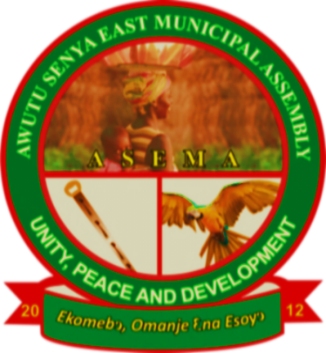

DISTRICT ASSEMBLY COMMON FUND BUDGET

FOR 2025 FISCAL YEAR

AWUTU SENYA EAST MUNICIPAL ASSEMBLY
(ASEMA)

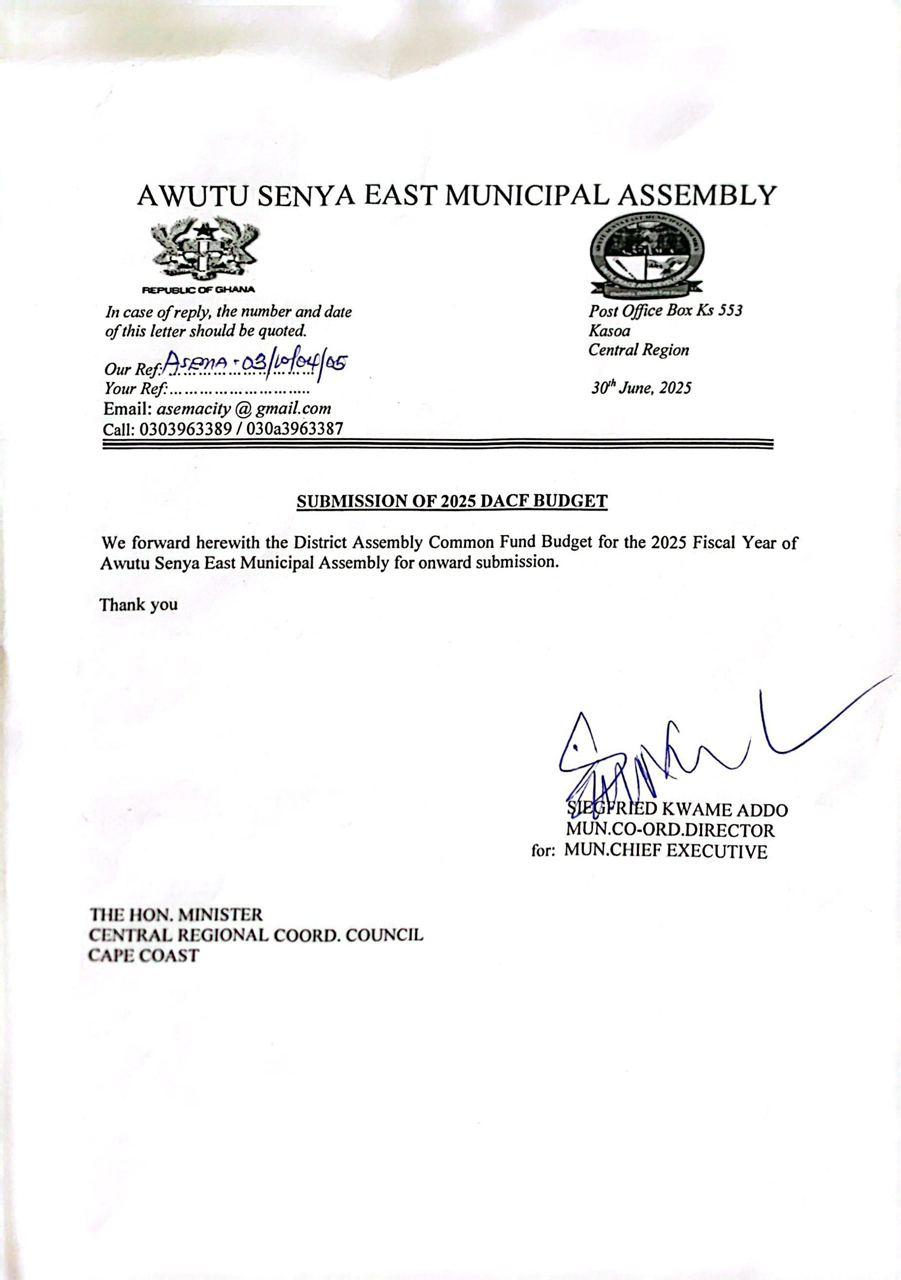

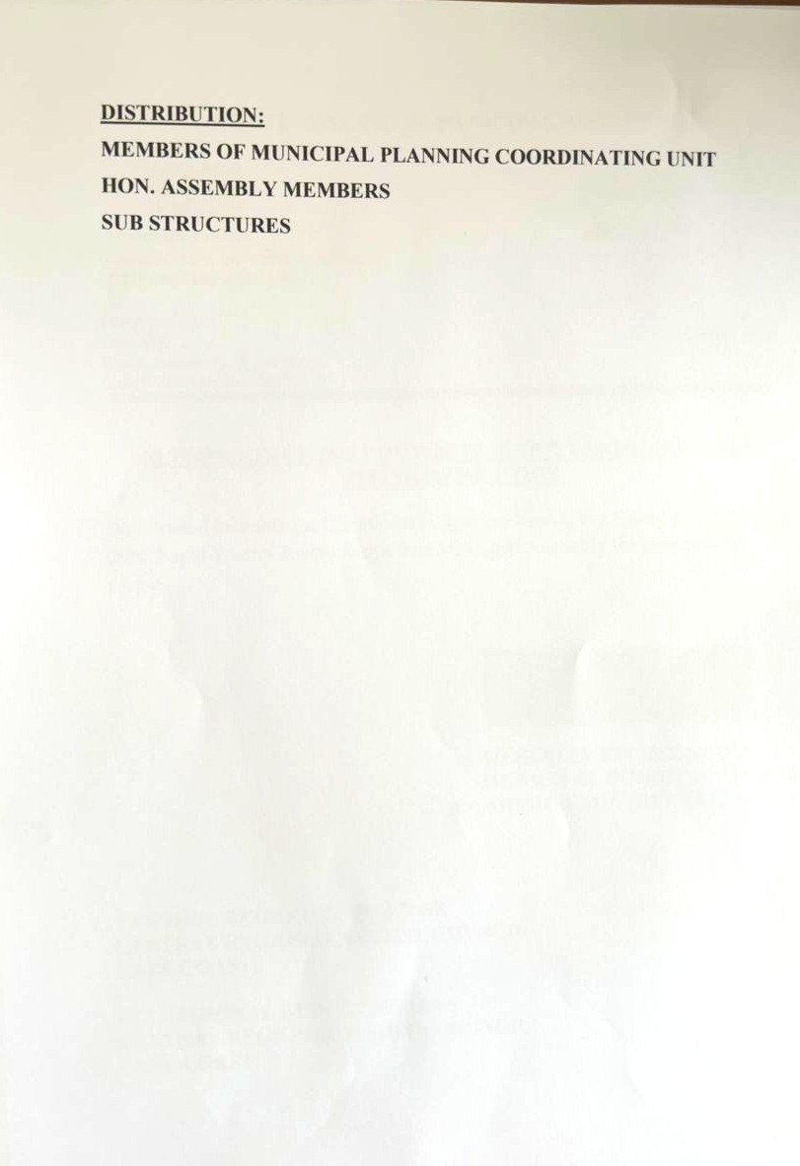

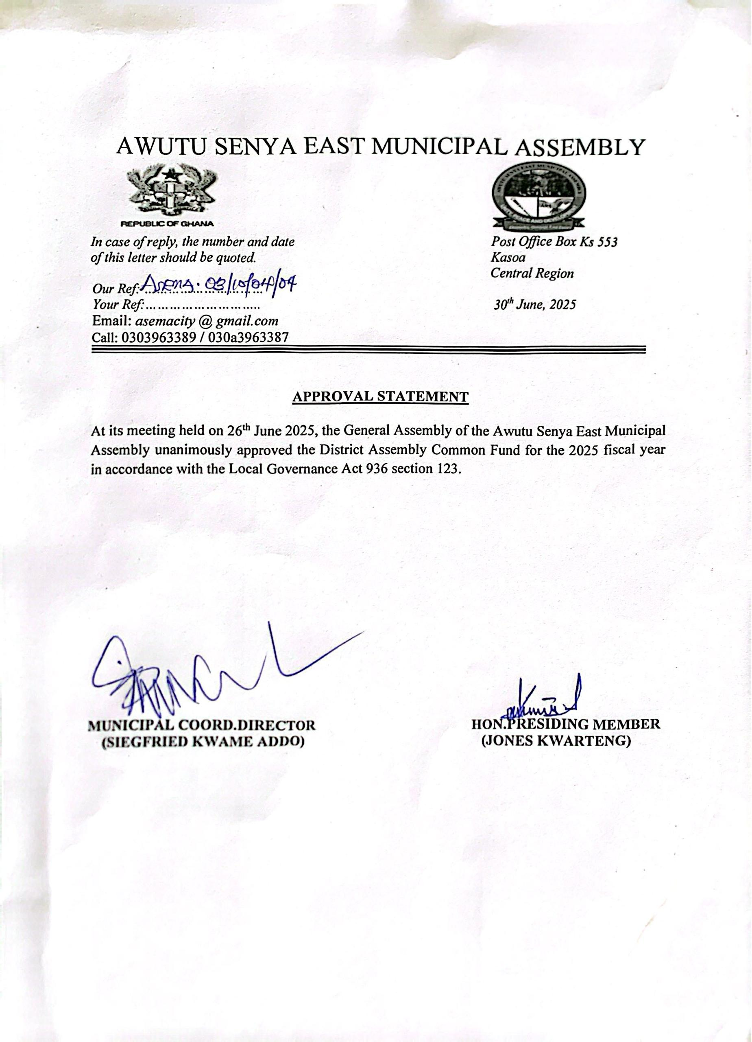

Table of Contents
SUBMISSION LETTER 1
APPROVAL STATEMENT 2
MUNICIPAL PROFILE 4
LOCATION AND SIZE 4
POPULATION…………………………………………………………………………………………..5
VISION 5
MISSION 5
DEVELOPMENT GOALS 6
CORE VALUES……………………………………………………………………………………………………7
FUNCTIONS 7
SPECIFIC OBJECTIVES 8
DISTRICT ECONOMY………………………………………………………………………………………………11
SOCIAL SERVICES……………………………………………………………………………………………...13
EDUCATIONAL FACILITIES…………………………………………………………………………………………13
HEALTH FACILITIES 12
WATER AND SANITATION, DRAINAGE AND WASTE MANAGEMENT 13
SOLID AND LIQUID WASTE DISPOSAL 13
TRANSPORT SYSTEM 13
KEY DEVELOPMENT ISSUES/CHALLENGES 14
DACF TREND ANALYSIS………………………………………………………………………………………………17
2025 DACF ALLOCATIONS………………………………………………………………………………………18

MUNICIPAL PROFILE
The Awutu Senya East Municipal Assembly (ASEMA) was established as a Municipality by Legislative Instrument (L.I) 2025 with Kasoa as its capital from the then Awutu Senya District in 2012 to exercise powers conferred on her by the Ministry of Local government, Decentralization and Rural Development under section (1) of the Local Government Act 1993, Act 462 (Local Governance Act 2016, Act 936). The rationale was to facilitate government’s decentralization programs and local governance system.
The municipality is one of the twenty-Two (22) administrative Districts in the Central region of Ghana. The Municipality is headed by a Municipal Chief Executive appointed by the President with approval by at least two-thirds of the Assembly Members. It has a presiding member who always chairs General Assembly meetings. There twenty-one (21) Assembly Members comprising six (6) appointed, thirteen (13) elected, the Municipal Chief Executive(MCE) and the Honourable Member of Parliament (MP). The Municipality has six (6) zonal councils, namely: Zongo, Ofaakor, Akweley, Opeikuma, Walantu, and Kpormetey. This constituency made up of thirteen electoral areas.

LOCATION AND SIZE
The Awutu Senya East Municipal is located in the Eastern part of the Central Region. It shares common boundaries with Ga South Municipal Assembly (in the Greater Accra Region) at the East, Awutu Senya District at the North and Gomoa East District at the West and South respectively. The Municipality covers a total land area of about 108.004 sq. km, about 1.1 percent of the total land area of the Central Region. Kasoa, the Municipal capital, is located at the South-Eastern part, about 24 km from Accra, the national capital. The major settlements of the municipal are Opeikuma, Adam Nana, Kpormertey, Ofaakor, Akweley, Walantu and Zongo.

POPULATION
The total population of the Municipality according to the 2021 Population and Housing Census(PHC) stood at 236,527, with a male population of 115,530 and a female population of 120,997. Which represent a male to female ratio of 0.49: 0.51 respectively. The population of the Municipality is 8.2 percent of the Central region’s population (2,859,821) and a growth rate of 0.9%. With the growth rate of 0.9%, the 2025 population of the municipality is projected at 245,042.
The Municipality has an urban population of 229,701 and a rural population of 6,826.
The figure below shows the nature of population density of the municipality.
Figure 1.0: Map of Awutu Senya East Municipal Assembly (Population Density)

VISION
- To become a well-developed Municipal Assembly that provides and facilitates excellent services to its people to ensure improvement in the quality of life of its people.

MISSION
- The Awutu Senya East Municipal Assembly exists to facilitate the improvement in the quality of life of the people in close collaboration with the private sector and other development partners in the Municipality through the mobilization and the judicious use of resources and provision of Basic Socio-Economic Development within the context of commitment to Equity, Accountability, and Excellence.

DEVELOPMENT GOALS
- To improve the quality and increase access to basic socio-economic Infrastructure, and enhance welfare services within Transparent and Accountable governance in the municipality.
- Create an enabling environment and encourage the participation of the Private Sector and Civil Societies in the development of the Municipality.
- Improve quality and increase access to economic, social and welfare services.

These are the critical goals arising out of the development challenges, which need to be tackled if the desired reduction of poverty and the subsequent improvements in the living standards of the people in the Municipality are to be achieved in a sustainable and integrated way.

CORE VALUES
The core values of the municipality are principles that the assembly upholds and are at the heart of its functions. These values are stressed on in dealing with all groups of the general public, without which the assembly ceases to exist. The core values of the Awutu Senya East Municipality include; People Oriented, Accountability, Fairness or Equity, Innovation, Loyalty and Excellence

Accountability.
- The assembly shall be responsible to the government and the public for their actions.

Fairness or equity
- The public will be treated with fairness in dealing with them
- No form of discrimination as against the public will be tolerated

Innovation
- Constantly improving services to meet changing demands and needs of the public.
- Committed to providing innovative ideas in problem solving and policy implementation.

Loyalty
- The assembly shall be faithful in the pursuit of the goals and aspirations of the municipality.
- The assembly owes allegiance to the general public to whom they have been called to serve.

Excellence
- Stress on quality, efficiency and high productivity
- Professionalism in dealings

People Oriented Approach
  - Treat people with respect and dignity
  - Foster team work and collaboration
  - The concerns and needs of the public are our priority
  - Recognize and reward hard work and accomplishment

FUNCTIONS
The section 46, sub-section 3 of the local governance Act, Act 462 (Local Governance Act 2016, Act 936) established the Municipal Planning Coordinating Unit (MPCU) to assist the Municipal Assembly to execute designated planning functions. The National Development Planning (system) Act, 1994, Act 480 defines the MPCU’s planning, programming, monitoring and coordination functions. The MPCU mandate is to set objectives that guided the development of the Municipality within the planned period of 2022–2025 under the President’s Coordinated Programme for Social and Economic Development; “An Agenda for Jobs: Creating Prosperity and Equal Opportunities for All” in which the government sought to propel the nation to sustain the middle income status (with a per capita income of at least US$1000) as well as the SDGs which are critical development issues of poverty and hunger, education, health (especially child and maternal mortality), gender equality and women’s empowerment, environmental sustainability and global partnership for development. These are deliberative, legislative and executive. According to section 6(3) of PNDCL 207 list them as follows.
- The Municipality is responsible for the overall development of the Municipality and shall ensure the preparation and submission to the Central Government for approval the development plan and budget for the Municipality.
- Formulate programmes and strategies for the effective mobilization and utilization of human, physical, financial and other resources of the Municipality.
- Promote and support productive activity and social development in the Municipality and remove any obstacles to initiative and development.
- Responsible for the development, improvement and management of human settlements and the environment in the Municipality.
- Initiate programmes for development of basic infrastructure and provide municipal works and services in the Municipality.
- In cooperation with appropriate national and local security agencies be responsible for the maintenance of security and public safety in the Municipality.
- Ensure ready access to the courts in the Municipality for the promotion of justice.

SPECIFIC OBJECTIVES
- To effectively mobilize internal revenue through expansion of revenue sources.
- To strengthen the skills and knowledge of staff through capacity building and professional trainings.
- To effectively monitor all implemented programmes and projects to ensure successful completion.
- To ensure general administration of the Assembly including the operationalization and functioning of the zonal councils.
- To strengthening spatial and land use planning system in the Municipality.
- To control and promote orderly and structured development in the Municipality.
- To increase inclusive and equitable access to education at all levels.
- To improve quality teaching and learning at all levels for better exams results.
- To improve quality health services through trainings and infrastructure development.
- To increase access to health delivery and improve OPD services.
- To create the enabling environment for SMEs to expand and create jobs for the youth.
- To provide quality extension services to farmers to ensure increase yield.
- To ensure that crops are handled well after harvest.
- To increase livestock and fish farming products.
- To safeguard the environment and ensure a clean Municipality.
- To ensure sustainable management of natural resources.

DISTRICT ECONOMY
ECONOMIC ACTIVITIES
Among the population above 15 years, 69.4 percent are economically active while 30.6 percent are not economically active. For the economically active, 92.5 percent were employed while 7.5 percent are unemployed. The economically active category had 93.4% and 91.6% as the proportion of employed males and females respectively. The occupation with the highest population is the service and sales sector (39.1%). The next occupation is those in the craft and related trades works with (24.0%). Craft related trades works are also the highest occupation among males with percentage of 31.7 while majority of females were found in the service and the sales sectors with 57.4 percent in the Municipality. Retail and wholesale, repair of motor vehicles and motorcycles industries employ majority of the population within the municipality.

AGRICULTURE ACTIVITIES
Agriculture sector produces crops, vegetables and rearing of animals for human consumption. Some of these crop, vegetables and animal reared include; maize, cassava, sweet potatoes, cabbage, onion, cattle, sheet, goat, rabbits and poultry.

Agriculture produce within the Municipality
PRODUCE/ANIMAL REARED | 2018 | 2019 | 2020 | 2021
Maize (MT) | 275.1 | 358.9 | 910 | 324
Cassava (MT) | 969 | 912 | 3,447.60 | 1386
Sweet pepper |  |  |  | 278.7
Cabbage |  |  |  | 576
Onion |  |  |  | 324.8
Cattle | 1,468 | 1,743 | 1,948 | 1,948
Sheep | 5,467 | 6,237 | 8,437 | 8,437
Goat | 6,451 | 7,216 | 7,516 | 7,516
Rabbit | 1, 427 | 2,000 | 2,300 | 3,517
Pig | 38,642 | 49,375 | 49,675 | 2,300
Poultry | 1,468 | 1,743 | 1,948 | 49,675

Local Economic Development
The local economy continues to generate more small and medium scale businesses in every part of the municipality. The businesses that are blossoming are the retailing and wholesaling, handicraft, mechanics, hair dressers, fashion designers, transport including motor bikes, water production and sales, small scale livestock farming, private institutions and pharmaceutical shops, etc. These businesses provide platforms for job creation and training for the teeming youth, they are handicapped in terms of funds to expand their businesses and also lack basic managerial skills.
There is the need to link most of these businesses to the financial institutions in the municipality and continue to engage them frequently to understand their basic challenges and to support them in addressing some. It is important to organize frequent training in management, client service and communication skills in collaboration with the financial institutions to help them understand the business environment and dynamics to help grow their business to mitigate growing youth unemployment in the municipality.
Industry
The type of industry that employs majority of the population 15 years and older in the Municipality is the Wholesale and retail, repair of motor vehicles and motorcycles. The industry employs 35.7 percent of the employed population 15 years and above in the Municipality. In addition, more females are found in the wholesale and the retail industry as compared to the other industries in the Municipality. It can be observed that 46.8 percent of the female population 15 years and older are in wholesale and retail industry compared to 24.4 percent males. Water supply; sewage waste management and remediation activities and real estate activities was the industry that employed least in the municipality as they were both 0.1 percent.

SOCIAL SERVICES
EDUCATIONAL FACILITIES
Educational facilities within the Municipality ranges from KG to the Senior High School. The Municipality has 21 KG facilities, 25 primary school facilities, 26 JHS school facilities and 1 Senior High School facilities which are all public institutions. The map below indicates the geographical spread of these public educational facilities within the Municipality.

Geographical Distribution of Public Educational Facilities
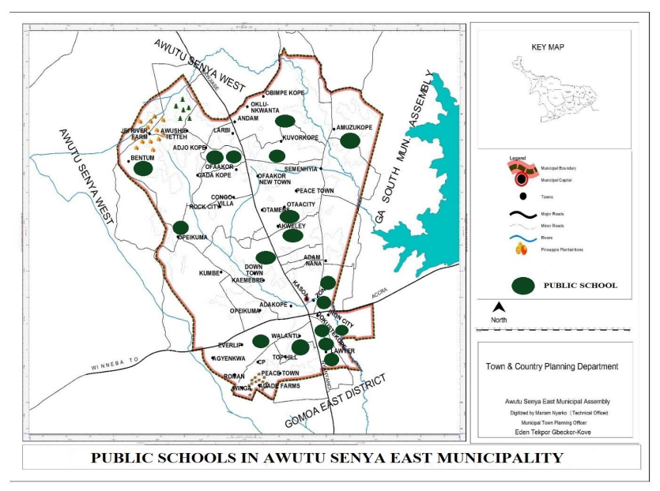

HEALTH FACILITIES
The Municipality has two different health institutions: the government and the private health institutions. There are a total of forty-three (47) health facilities in the Municipality as of December, 2020. Twenty-six (30) are government facilities and seventeen (17) private.

Type of Health Facilities
TYPE OF FACILITY | NUMBER
Community Health Post Service Compounds(CHPs) | 24
Health Centers | 2 New Market, Akweley and Gada
Hospital | 1 CP Walantu
Polyclinic | 1 Kasoa

Staff Strength in Health Sector
Staff | Staff Strength
Doctors | 18
Physician Assistant | 9
Midwives | 89
Professional Nurses | 131
Community Health Nurses | 69
Enrolled Nurses | 126

WATER AND SANITATION, DRAINAGE AND WASTE MANAGEMENT
There are 13 major sources of drinking water within the Municipality. Sachet water and pipe-borne are the major sources of water representing 36.5 percent and 30.9 percent respectively and more than two-thirds of households’ drink from these two sources. 9.5 percent of the drinking water comes from the water tankers and vendors and 6.5 percent access water from the public stand pipe. The rain water, borehole/pump/tube wells and protected wells are used by 6.4 percent of the households.
For domestic purposes, pipe-borne outside the dwelling unit serves the highest proportion of household representing 48%, followed by the water tankers and vendors representing 14 percent. In all, 43.8 percent of the households within the Municipality have access to portable water.

SOLID AND LIQUID WASTE DISPOSAL

The commonest form of solid waste disposal among household in the Municipality is burning, which constitute (43.4 percent) followed by collection by waste management companies which represents 29.9 percent. Public dump using container and open space representing 8.3 percent and 7.4 percent respectively.
Loitering (54.7 percent) is the main liquid waste disposal method used by households in the Municipality. The other means of the disposing liquid waste include; throwing on the street/outside compound (25 percent), throwing into gutters (11.3 percent) and throwing into pit (soak away) (3.2 percent)

TRANSPORT SYSTEM
The total road network in the Municipality is 625 km of which 65.6km are paved and 559.45km unpaved. The rest constitute gravel and earth roads located within various communities in the municipality. An unknown length of roads has also not been assessed. The proportion of good roads is woefully inadequate and does not meet the demands of the people within the municipality. With the budgetary allocation for routine maintenance works from the Ghana Road Fund, a total length of about 70km within the Municipality are graded annually.

key development issues/challenges
KEY CHALLENGES | RANK
Inadequate Potable drinking water | 3rd
Poor Security/inadequate streetlights | 2nd
Inadequate Health facilities | 6th
Poor Environmental Sanitation | 4th
Inadequate access to educational facilities | 5th
Inadequate access roads/drainage | 1st

DACF TREND ANALYSIS (2021-2024)
YEAR | ALLOCATIONS (GHS) | ACTUALS RECEIVED (GHS) | VARIANCE (GHS) | PER. %
2021 | 5,858,297.00 | 962,967.36 | 4,895,329.64 | 16.44
2022 | 5,128,305.03 | 2,626,096.54 | 2,502,208.49 | 51.21
2023 | 5,778,935.27 | 1,093,931.83 | 4,685,003.44 | 18.93
2024 | 4,812,036.79 | 2,951,276.29 | 1,860,760.50 | 61.33
GRAND TOTAL | 21,577,574.09 | 7,634,272.02 | 13,943,302.07 | 35.38

2025 DISTRICT ASSEMBLY COMMON FUND (DACF) ALLOCATIONS
ACTIVITY | LOCATION | BUDGET/ALLOCATION | JUSTIFICATION
TOTAL ALLOCATION |  | 29,513,992.60
Government Flagship Programme
24-HOUR ECONOMY MARKET (25%)
Construct 24-hour Economy MODERN Market (Lockable Stores) | Kasoa CBD | 7,378,498.15 | This amount is set aside to construct a new modern 24-hr operational market at the Central Business Districts
Sub-total |  | 7,378,498.15
HEALTH FACILITIES (10%)
Construct and furnish 1No. CHPS | Ofaakor | 737,849.82 | To improve quality health services through trainings and infrastructure development
Construct and furnish 1No. CHPS Compound | Amuzukope | 737,849.82 | To improve quality health services through trainings and infrastructure development
Construct Maternity Block | Opeikuma Community Centre CHPS | 480,000.00 | To improve quality health services through trainings and infrastructure development
Rehabilitation of New Market Health Center and Gada Health Center | New Market & Gada | 500,000.00 | To improve quality health services through trainings and infrastructure development
Provide support for control of Malaria, Cholera, Rabies, Mpox, Schistomiasis and other disease outbreaks  (Event Based Surveillance) | Entire municipality | 495,699.62 | This amount is set aside to create awareness and educate citizenry on prevention methods on malaria, cholera, rabies, Mpox, Schistosomiasis and other disease outbreaks
Sub-total |  | 2,951,399.26
EDUCATIONAL FACILITIES (10%)
Construction of 1No. 6 unit primary classroom block with office, changing room, staff common room, wash rooms at Camp Prison | Camp Prison | 1,222,133.08 | To increase inclusive and equitable access to education at all levels
Construction of 1No. 3 unit JHS classroom block | Camp Prison | 450,000.00 | To increase inclusive and equitable access to education at all levels
Construction of 1No. 2unit KG classroom block | Awushie Tetteh | 450,000.00 | To increase inclusive and equitable access to education at all levels
Rehabilitate/Renovate existing Education facilities | Selected schools in the municipality | 570,000.00 | This amount is earmarked to Rehabilitate /Renovate existing Educational facilities namely Banat school, Salmali School, Ofaakor Basic School, Islamic Research Basic School, Akweley St. Mary's Basic School, Gada Basic School, Zakarikope, Amuzukope, Iron city, Methodist schools
Scholarships/Award for students | Selected students in the municipality | 74,266.18 | This amount is allocated to support Seven tertiary brilliant but needy students in the municipality
Organize My First Day At School activities | Selected schools in the municipality | 40,000.00 | This amount is set aside to cater for refreshment for KG pupils and fuel for MCE and Education Directorate to increase equitable access to education at all levels.
Monitor W.A.S.S.C.E | Secondary school in the municipality | 45,000.00 | To improve quality teaching and learning at all levels for better exams results.
Support sports in schools | Entire municipality | 50,000.00 | The budget has been allocated to support inter-circuit culture festivals and sporting activities in schools.
Kasoa youth empowerment | Entire municipality | 50,000.00 | To create the enabling environment for SMEs to expand and create jobs for the youth
Sub-total |  | 2,951,399.26
WATER FACILITIES (10%)
Construction of 9No. mechanised borehole | Slaughter house, Iron City health center, Opeikuma Township and 6 cluster of sch. | 360,000.00 | This amount is set for the construction of 5No. mechanised borehole at the Slaughter house, Iron City, Shalom, Opeikuma and Krispol City Health Centre@GHC40,000 each to increase access to safe water for all in the municipality.
Extend and expand pipe-borne water to communities | Selected communities  Alico-Amuzukope communities, congo villa rock city, jei river | 2,591,399.26 | This amount is set aside to extend pipe-borne water to selected communities in the municipality to increase access to safe water for all in the municipality.
Sub-total |  | 2,951,399.26
ENVIRONMENTAL SANITATION (10%)
Evacuate and dispose refuse dumps |  | 160,000.00 | To safeguard the environment and ensure a clean Municipality
Acquisition of sanitary tools |  | 30,000.00 | This amount is to be used for purchasing sanitary tools for the Assembly to ensure a clean municipality.
Organize National Sanitation Day Clean up exercise |  | 80,000.00 | To safeguard the environment and ensure a clean Municipality
Procurement of (4) skip container |  | 200,000.00 | This amount would be used to purchase 4 No. skip containers to address sanitation situation in the Municipality.
Procurement of motorbikes  (4No.) |  | 100,000.00 | This amount is earmarked to purchase and license motorbikes for monitoring sanitation and other environmental issues in the Municipality.
Sanitation Taskforce operation |  | 110,000.00 | To safeguard the environment and ensure a clean Municipality
Dredge/Desilt the Okrudu River |  | 350,000.00 | This amount is to aid the desilting of drains @GHC50,000 each and dredging of the Okrudu river (3.75km) to prevent flooding.
NADMO Activities |  | 180,000.00 | This figure is to educate and sensitize the citizenry on disaster prevention and mitigation and also to purchase relief items for disaster victims, train Disaster Volunteering Groups and Staff Capacity Building
Fumigation |  | 418,600.00 | To safeguard the environment and ensure a clean Municipality
Support sanitation improvement package |  | 523,250.00 | To safeguard the environment and ensure a clean Municipality
Undertake climate related activities |  | 42,799.26 | This amount is earmarked to organize stakeholders’ meetings on climate change adaptation, mitigations, behavioral change etc.
Undertake National Tree for Life planting exercise |  | 30,000.00 | This amount is set aside to green public facilities, homes and Assembly compound
Dislodging of government institution septic tank |  | 26,750.00 | This amount is earmarked for the dislodging of septic tanks belonging to public institutions and agencies in the municipality
Construction of pick-up sites | Joemends and Zongo | 420,000.00 | To safeguard the environment and ensure a clean Municipality
Conduct sensitization on WASH activities |  | 30,000.00 | To safeguard the environment and ensure a clean Municipality
Maintenance of footbridge | Iron City-Zongo | 250,000.00 | This amount is set aside for the maintenance of footbridges within the municipality to prevent fatal incidents during flooding
Sub-total |  | 2,951,399.26
ADMINISTRATION (5%)
Procure office fittings, equipment and stationery |  | 145,942.63 | The amount is set aside to cater for the procurement of office furniture, office equipment and stationeries to enable effective administration
Maintenance, insurance and running expenses of official vehicles and other equipment |  | 107,742.27 | This amount is to cater for running cost of official vehicles to perform official tasks
Documentation of Assembly lands |  | 50,000.00 | To strengthen spatial and land use planning system in the Municipality
Conduct Monitoring and Evaluation activities |  | 50,000.00 | The budget is earmarked for allowances, fuel, maintenance, refreshment and other related monitoring expenses.
Support MPCU activities and statutory meetings |  | 80,000.00 | This budget is to cater for allowance and refreshment for statutory meetings and MPCU activities
Support implementation of agriculture activities |  | 95,000.00 | To provide quality extension services to farmers to ensure increase yield
Preparation of 2026-2029 strategic plan and annual risk base internal audit |  | 50,000.00 | This amount is earmarked for the preparation of the annual risk base internal audit plan
Organize capacity building |  | 40,000.00 | To strengthen the skills and knowledge of staff through capacity building and professional trainings
Support Security Operations |  | 45,000.00 | This budget is set aside to support security operations to strengthen security in the municipality
Preparation of 2026-2029 Municipal Medium Term Development Plan (MMTDP) |  | 70,000.00 | This amount is set aside to prepare the MTDP for 2026-2029 to improve service delivery in the Municipality
Implement Street Naming and Property Addressing |  | 70,000.00 | To control and promote orderly and structured development in the Municipality
Public Education and Sensitization |  | 50,000.00 | This amount is set aside for activities related to public education and sensitization of citizenry on pertinent issues.
Prepare 2026-2029 Composite Budget and fee-fixing |  | 50,000.00 | This is earmarked to organize stakeholder’s consultative meetings on the preparation of the 2026-2029 Composite Budget and Rates and Fee-Fixing Resolution
Support Culture and tourism |  | 50,000.00 | An amount is set aside for the promotion of culture and tourism in the Municipality to enhance revenue generation.
MCE's Engagement with communities |  | 150,000.00 | This amount is set aside for MCE's engagement with the communities to know their challenges and interact with the constituents.
Support the operationalization and functionality of the six (6) zonal councils and support Assembly Members' Community Engagement |  | 95,000.00 | To ensure general administration of the Assembly including the operationalization and functioning of the zonal councils
NACAP Activities |  | 35,000.00 | This amount is earmarked for NACAP meetings i.e. Public education and Sensitization
NALAG | .32% of the total allocation | 94,444.77 | This amount is set aside to cater for activities of National Association of Local Authorities in Ghana
HIV/AIDS | .5% of the total allocation | 147,569.96 | This amount is set aside to cater for public sensitization and education on HIV/AIDS.
Sub-total |  | 1,475,699.63
SCHOOL FURNITURE (10%)
Procure 285No. Hexagonal tables and 1,710 Chairs for KG schools | Selected schools in the municipality | 750,000.00 | This amount is set aside for the procurement of school furniture to be distributed to selected KG schools
Procure 1,120No. dual desks for public primary schools | Selected schools in the municipality | 901,399.26 | This amount is set aside for the procurement of school furniture to be distributed to selected primary schools
Procure 1,777No. Mono Desks for JHS | Selected schools in the municipality | 800,000.00 | This amount is set aside for the procurement of school furniture to be distributed to selected Junior High Schools
Procure 260No. cupboards | Selected schools in the municipality | 500,000.00 | This amount is set aside for the procurement of cupboards for schools in the municipality for the storage of stationery’
Sub-total |  | 2,951,399.26
LEGACY PROJECTS (20%)
Completion of two-bedroom semi-detached bungalow (DACF-RFG) | Ofaakor Jei-River | 400,000.00 | This estimate is to be used to complete MCD’s bungalow
Furnishing works of 1No. Zonal Council (DACF-RFG) | Adam Nana | 50,000.00 | This amount is earmarked for the furnishing works at New Market Zonal Council (Adam Nana)
Complete 1No. 3 seater WC toilet at Gada M/A school (IGF) | Gada M/A | 15,000.00 | This amount is to be used to complete a 3-seater WC toilet at Gada School
Complete 1No. 3 seater  WC toilet at Akweley M/A school (IGF) | Akweley M/A | 15,000.00 | This amount is to be used to complete a 3-seater WC toilet at Akweley School
Complete1No. 8-seater toilet facility and ancillary works (CODA) | Iron City | 200,000.00 | This amount is to be used to complete a 1No. 8 seater toilet at Iron City
Completion of 1No. 4 classroom block and 3No. toilet facility (SIF) | New Market | 500,000.00 | This amount is to be used to complete a 1No. 4 classroom block and 3 no, toilet facility at New Market.
Complete 1No. two-storey12-Unit classroom block with office, staff common room, store and ancillary facilities at Amuzukope Cluster of Schools (GETFund) | Amuzukope | 1,851,617.53 | This amount is earmarked for the completion of a 1No. two storey 12-Unit classroom block started at Amuzukope
Complete and renovate pavement works and barricade (GSCSP) | Kasoa Old Market | 600,000.00 | This amount is set aside for the completion and renovation of pavement works and barricade at Kasoa Old Market
Support community initiated projects |  | 498,382.47 | This amount has been set aside to support communities that have started projects and need assistance like cement, iron rods, etc. from the Assembly.
Culvert and approach filling | Otamens | 400,000.00 | This amount is set aside to cater for cost of constructing of culvert and approaches filling at Otamens
Upgrade of road | Datus to Columba road | 1,000,000.00 | This amount is allocated to upgrade the Datus to Columba road to enhance economic activities at Kasoa New Market
Maintenance of Assembly block (IGF/DACF) | Jei-River | 122,798.52 | This amount is set aside to cater for maintenance of the assembly block to enhance the effective operations of the Assembly
Maintenance of streetlights (GSCSP) | Entire municipality | 250,000.00 | This is an allocated for the maintenance and replacement of streetlights in the municipality to enhance security
Sub-total |  | 5,902,798.52
GRAND TOTAL |  | 29,513,992.60

